**HOTEL ORDERING APPLICATION**

**MEMBER DETAILS:**

|  |  |  |
| --- | --- | --- |
| **ROLLNO** | **NAME** | **ROLE** |
| CB.EN.U4CSE19202 | A. SUKEERTHI | PROJECT MANAGER |
| CB.EN.U4CSE19204 | A. THARUN KUMAR REDDY | BUISINESS ANALYST |
| CB.EN.U4CSE19211 | B. PAVAN | TESTER |
| CB.EN.U4CSE19216 | G.SAI KAVYA | SOFTWARE ENGINEER(WEB) |
| CB.EN.U4CSE19221 | K. PRANAY | SOFTWARE ENGINEER |

**ABSTRACT:**

Online food order system is a website designed to make the work of a user easy to order food items. Going to hotel and having food is not possible sometimes due to the busy schedule of the people. So, we have come with the interesting website which allows users to order food items from their desk and food will be available in the short span of time to their desk. Restaurant employees then use the orders through an easy to navigate graphical interface for efficient processing.

**STAKE HOLDERS:**

* Customers
* Admin
* Delivery boy

**MODULES:**

1. Create an account
2. Manage their account
3. Login to the system
4. Navigate restaurant’s menu
5. Select item from menu
6. Add an item into their current order
7. Remove an item/ all item from their order
8. Provide payment details
9. Place an order
10. Receive confirmation in the form of order of a number
11. View order placed.

**TABLE:**

|  |  |  |
| --- | --- | --- |
| **tbl_admin** | | |
| **Primary** | id | int(10) |
| full_name | varchar(100) |
| username | varchar(100) |
| password | varchar(255) |

|  |  |  |
| --- | --- | --- |
| **tbl_order** | | |
| **Primary** | id | int(10) |
| food | varchar(255) |
| price | varchar(150) |
| qty | decimal(10,2) |
| total | varchar(255) |
| order_date | int(10) |
| status | varchar(10) |
| customer_name | varchar(10) |
| customer_contact | type |
| customer_email | type |
| customer_address | type |

|  |  |  |
| --- | --- | --- |
| **tbl_category** | | |
| **Primary** | id | int(10) |
| title | varchar(100) |
| image_name | varchar(255) |
| feature | varchar(10) |
| active | varchar(10) |

|  |  |  |
| --- | --- | --- |
| **tbl_food** | | |
| **Primary** | id | int(10) |
| title | varchar(150) |
| description | varchar(255) |
| price | decimal(10,2) |
| image_name | Varchar(255) |
| **foreign** | category_id | int(10) |
| featured | varchar(10) |
| active | varchar(10) |

**REPORTS:**

1. Food items- We can generate the report for which item has been ordered mostly so far.
2. Restaurants- We can generate the report for restaurants from which mostly users order from.
3. Food items- We can generate the report for food items which has most likes.
4. Users- We can generate the report for users who frequently order.

**TECHNOLOGIES USED:**

It is a web application.

Front-end- HTML, CSS, JS

Back-end- MONGODB, python

**LIMITATIONS/ASSUMPTIONS:**

* Hotel ordering software is a website which can be accessed using laptop.
* System supports native language of country (English).
* The system is secured to restrict no of people enter the system to make changes in menu and items.
* System will be secured to grant access rights only to the system administrator. For this a login id and password will be assigned and would be changed. Password won’t be visible to onlookers while typing for increased security.
* If order is cancelled total amount will be refunded back.

**REQUIREMENTS:**

**USER REQUIREMENTS:**

* user must be able to register and login into the account using credentials like username and password.
* User must be able to view/add/delete the ordered food items list.
* User must be able to track the delivery status.

(Booked->on the way-> delivered).

* User must be given payment options like cash on delivery/card.

**ADMIN REQUIREMENTS:**

* Add a new/update/delete vendor from menu.
* Add a new/update/delete food category from menu.
* Add a new/update/delete food item from menu.
* Admin must have option to update price.
* Admin should be able to update additional information like description of food item, photo of the food item.

**MANAGER REQUIREMENTS:**

* He must be able to track the restaurant’s, from where the food is supplied.
* He should be able to see the feedback.
* He should have the track of all the employees.

**DELIVERY BOY REQUIREMENTS:**

* Delivery boy should be provided with details of the user like phone number, location etc.
* Delivery boy must be able to update the data whether the food is accepted/prepared/couriered/on the way.
* He should be provided with option in order to enter number of food orders he has delivered per day.

**EPICS, USER STORIES, TASKS**

**SIGN UP AND LOGIN - A. THARUN**

* **"As a new user, I want to register by creating a username, mail, phone number and password so that my data will be saved."**
* As a user, for entering username, password and other details text box must be given.
* As a user, I want confirm password text box.
* As a user, I want register button.
* As a user, I need a pop-up window saying “successfully registered.”
* As a user, if I didn’t enter any field, it should show warning saying “please fill this box.”
* As a user, when I click ok on popup window it should take me to login page
* All the fields must be validated with some constraints
* **"As a registered user, I want login with my username and password so that system I can authenticate and I can trust it."**
* As a user, to enter username and password text box should be given.
* As a user, I need a login button.
* As a user, when I click on login it should show pop-up window saying “successfully logged in”.
* When I click ok on pop-up window it should go to home page.
* As a user, if I didn’t enter any field, it should show warning saying “please fill this box.”
* As a user, if I am not already registered user it should alert with message saying “please register.”
* **"As a user, I need a functionality which will lock account automatically after too many failed attempts so that my account is secure."**
* As a user I want to have account locked if it fails for 3 times.
* As a user I want a message to my phone number if it is failed more than 2 times.
* As a user I want a message on website after 2 failed attempts saying “your account will be locked.”
* As a user I want a verification mail if it is logged in through any other device except mine.
* As a user I want a popup message when any details are wrongly typed.
* As a user
* **"As a user if I forget password, I need to reset password so that I can recover my account."**
* As a user I want a forget password link when clicked on it should take me to the page where I can change password
* After changing password, it should send a verification mail
* After verifying in mail, it should show a popup saying “your password is changed”
* While entering password validation must be given
* As a user if easy password is entered it should show some conditions to set strict password
* After changing password, it should take me to login page.
* **"As a user, I need be able to login through google/ Facebook login supports so that it would be easy to login."**
* As a user I need Facebook and google icon
* As a user when I click Facebook/ google icon it should directly connect.
* As a user it should show me options among various google accounts to which account it should be synced to.
* As a user when account is synced It should go to home page.
* **FILTERS FOR SEARCH -G.SAI KAVYA**
* **"As a user, I want functionality which filters pure veg food items so that it is easy to order"**
* As a user, I want the pics of the category food
* As a user, I want three buttons
* As a user, when I select the button, the color should be changed
* As a user, when I select it should be showing the selected category food items
* As a user, I want most famous food items in their respective category
* As a user, when I press the back button i should come back to the home page
* **"As a user, I want functionality which filters according to cuisine so that it is easy to order related to cuisine I want."**
* As a user, I should have a text box
* As a user, I want the text box with validation
* As a user, I should be able to see the all items related to that cuisine
* as a user is should have the pictures of that items
* as a user, when I click on that picture it should be able to see in which restaurants it is available with price
* As a user, when I press the back button i should come back to the items page
* As a user, when I press the back button i should come back to the home page
* **"As a user I want functionality to filter according to restaurant name so that I can order from favourite restaurant."**
* As a user, I should have a drop-down list
* As a user, I want the list should contain the hotel names
* As a user, I want it should have a scrolling option
* As a user, when I move cursor on the restaurant it should be highlighted with color
* When the restaurant is selected it should able to see the restaurant menu with price
* As a user, when I press the back button i should come back to the home page
* **"As a user, I want a functionality to filter according to rating so that I can order easily from restaurant which has good rating."**
* As a user, I should be able to see the top-rated restaurants
* As a user, it will be easy if we have a logo pics of the restaurant
* As a user, there should be ranking for these restaurant
* As a user, I should be able to see the discount offer for the restaurant
* As a user, when i click on the logo i should be able to see the hotel menu with price
* As a user, when i i press the back button i should come back to the home page
* **"As a user, I should be able to see new arrivals so that it is easy to order."**
* As a user, I should be able to see the new arrivals as a slides
* As a user, I should be able to see the food item picture in the slide
* As a user, I should be able to see the discount offer at the left of that slide
* As a user, I should be able to see the order now option in the slide itself for the new arrivals
* As a user, I want it should be at the top of the home page
* As a user, when I press the back button i should come back to the home page
* **RATE/REVIEW -K. PRANAY**
* **"As a user, I should be able like/dislike restaurant so that other users can be benefitted."**
* As a user, I need a thumbs and thumbs down symbol to like or dislike.
* As a user, after liking/disliking food item it should show a message saying “you liked/disliked the food”
* As a user, I need a storage for liked food items.
* When the food item is liked it should be automatically shown in liked food items.
* As a user, after I like the food some preferences from same restaurant or same cuisine or something related to it should be shown.
* As a user, if I dislike the food, it should ask for reason.
* **"As a user I need a star rating system so that rate your service."**
* As a user I need 5 stars to be displayed to rate the service.
* As a user if I give rating the start should turn to dark color
* As a user it should show the popup notification after receiving saying “please rate our service.”
* As a user if I give poor rating it should ask for reason
* As a user I need a comment box to write about your service
* After rating it show popup window saying “thanks for rating our service.”
* **"As a user I need a star rating system to rate food so that I can rate food item."**
* As a user I need 5 stars to be displayed to rate the service.
* As a user if I give rating the start should turn to dark color
* As a user if I give 5 stars to any food it should show preferences having 5 stars of same restaurant or same cuisine.
* As a user it should display the number of stars (like 4.5/5) given by customer beside star.
* As a user if it has 5 stars rating it should show whether there is offer or not.
* As a user if I click on any rating number it should open the food item and reviews of the food.”
* **"As a user I want to know the reviews of food bloggers/foodies so that I know how good a restaurant is."**
* As a user I need a list of food bloggers in the website.
* As a user I need a separate row to see the reviews of food bloggers on food.
* As a user I need a review of food bloggers on specific restaurant.
* As a user, I need a button to follow or unfollow them
* As a user, I should have an option to see how many followers do food blogger have.
* As a user, I must be able to see details when I clicked on their name like picture of them, place.
* **"As a user I should be able to give feedback so that other users can benefit."**
* As a user I need comment box to give feedback on food
* As a user I should have option to see the feedbacks of other users when I click on food.
* As a user I must be able to send feedback about the website.
* As a user, I need a submit feedback button.
* As a user, I need a small box which shows number of feedbacks given on food/restaurant.
* As a user after clicking on submit feedback it should show popup saying “thank you for sending feedback”

* **ONLINE ORDERING -SUKEERTHI**
* **"As a user I want to add/delete/edit food items in the cart so that it saves time."**
* As a user I need a button showing add to cart.
* As a user It should show the buttons add and delete
* As a user if I give add to cart it should show popup saying “successfully added to cart”
* As a user if the item is added/deleted it should show toast message saying “your cart is modified and updated.”
* As a user I need a submit cart button to submit the cart list
* As a user total amount should be displayed.
* As a user after giving submit button it should go to payments page.”
* **"As a user I need a preference in the homepage so that I am interested in your app."**
* As a user I need a picture of food item in homepage
* As a user it should show the price of the food item on picture
* As a user I need a button which shows number of stars given on food item in homepage
* As a user I need a cash offers available on the picture of food item in homepage
* As a I need a box showing with in how much time it can deliver food
* As a user I need the color for veg/non-veg on that picture.
* **"As a user, I must have option like cash on delivery and card payment and e-wallet so that it is easy to order in currently available mode of payment.”**
* As a user after card is submitted it should come to payments page
* As a user in payments page, I need a button to select cash on delivery or card payment
* After giving card payment it should have box to show Paytm, google pay…
* After giving cod/ cash payment it should ask for address to be delivered
* As a user it should show the total amount with tax while payment
* As a user after doing payment, it should show a message saying your payment is successful
* As a user it should send a msg to phone number after payment.
* **"As a user, I should have offers and coupons so that users can benefit."**
* As a user I need a button which shows food items having certain offer
* As a user when I click on offers button it should display foods having 50% offer, deals on top-rated, deals on fastest
* As a user I need a option it should show the offer amount and restaurant.
* As a user I must have use code text box
* As a user, I need a submit button to submit the code.
* As a user, it should display toast message saying your code is successful
* As a user after getting successful it should go to payments page
* **"As a user, I must be able to track the status of delivery boy so that I can wait accordingly."**
* As a user I should be able to see the photo of delivery boy.
* As a user mobile number of delivery boy must be displayed.
* As a user I need a button saying “show delivery boy location”
* As a user, after clicking button it should take me to present location of delivery boy
* As a user, I must have the option to call him if he is confused with address.
* As a user I must have button saying “delivered”.

* **ADMIN -SUKEERTHI&KAVYA**
* **"As an admin I must be able to add/delete/update the food item so that I can modify the menu."**
* As an admin, i should have the symbols of plus and minus
* As an admin, when i selected any of this option it should be able to change the color
* As an admin, when I click on the food item photo it should give me the options
* As an admin, i want to update the photo option
* As an admin, I want the option to update the description of the food item
* As an admin, when i press the back button, it should go to home page
* **"As an admin I must be able to update the price so that I can change prices."**
* As an admin, I should have the photo like price updation
* As an admin, when i press that i should have the restaurant’s menu
* As an admin, when i click on any restaurant it should show the hotel menu
* As an admin, to the right of that menu it should show the increase and decrease symbol
* As an admin, when i click update i should get the message like the prices has updated
* As an admin, when i press the back button, it should go to home page
* price
* **"As an admin I must be able to add the details of coupons and offers."**
* As an admin, I should have the photo like coupons
* As an admin, when i press it should have plus and minus symbol
* As an admin, I want it to show the time so that i can fix the coupons validation
* As an admin, I should be able to add many coupons at a time
* As an admin, I should have add option in the bottom
* As an admin, when I press the back button, it should go to home page
* **"As an admin I should be able to add information of delivery boy so that I can update the details**
* As an admin, i should have an option to update the delivery boy details
* As an admin, when i click on it should take me to another page which contains the form
* As an admin, I should be able to fill the details in the from
* As an admin, I need validation for forms so that their won’t be any chance of missing the details
* As an admin, I should have the submit option and i when i submit i should get a message like this has been submitted
* As an admin, when I press the back button, it should go to home page
* **"As an admin, I should be able to update restaurants so that I can easily modify the restaurant details."**
* As an admin, i should have the symbols of plus and minus
* As an admin, when i selected any of this option it should be able to change the color
* As an admin, when i click on the restaurant logo photo it should give me the options
* As an admin, i want to update the photo option
* As an admin, i want the option to update the description of the restaurant
* As an admin, when i press the back button, it should go to home page
* **DELIVERY BOY -B. PAVAN**
* **"As a delivery boy I should get notified about the orders so that I can accept the order."**
* As a delivery boy, I must get notification saying “new order”
* As a delivery boy after clicking on notification I must be able to see the food items and restaurant details
* After seeing the restaurant details, I must have button to see details of the customer
* As a delivery boy I must have button to accept the order.
* As a delivery boy I should get a toast message saying “you have accepted the delivery.”
* After accepting the delivery, it should take me to google maps to deliver to specified location
* **"As a delivery boy, I should be able to acknowledge that delivery is successful to admin so that admin knows the delivery status."**
* As a delivery boy I should have button to send delivery status to admin
* As a delivery boy I should have scroll down menu like accepted, denied, on the way, delivered.
* As a delivery boy, after giving the acknowledgement to admin I should get a message saying your status has been sent.
* As delivery boy, I should be able to get notification from admin that status is known
* **"As a delivery boy, I should be able to know the customer and restaurant address so that I can get food from restaurant and order to customer."**
* As a delivery boy, I should have button to retrieve the address
* As a delivery boy, after clicking on address it should show me how much time it takes to deliver.
* As a delivery boy, I must be able to have the photo of restaurant.
* **"As a delivery boy, I should be able to accept the order so that I can get the order information."**
* As a delivery boy I must have buttons saying access, deny
* If access button is given it should show details
* As a delivery boy, if deny button is given it will display the pop-up message saying “you have denied the order.”
* As a delivery boy, if access button is given then you will have text box to add tips and submit button to submit the tip
* If tip is accepted by the customer, you will get a message saying “your tip is accepted.”
* As a delivery boy, I should get a notification saying “you have successfully delivered.”

* **"As a delivery boy, I should be able to notify delivery status to the customer."**
* As a delivery boy I should have button to send delivery status to admin
* As a delivery boy I should have scroll down menu like accepted, denied, on the way, delivered.
* As a delivery boy, I must have option to notify the customer if there is any late delivery due to some reasons

**INVISION APP:**

**LINK:** [**https://projects.invisionapp.com/freehand/document/1verWTYp1**](https://projects.invisionapp.com/freehand/document/1verWTYp1)

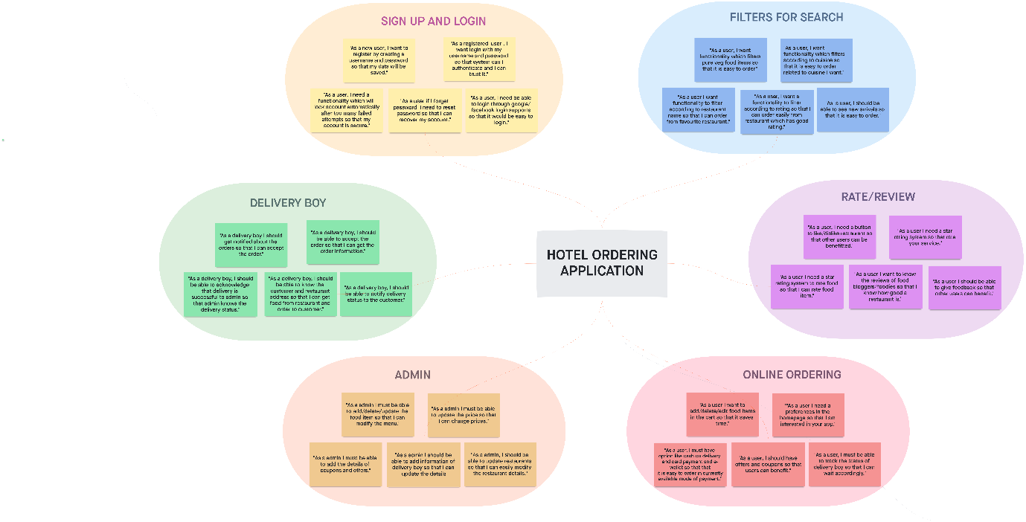

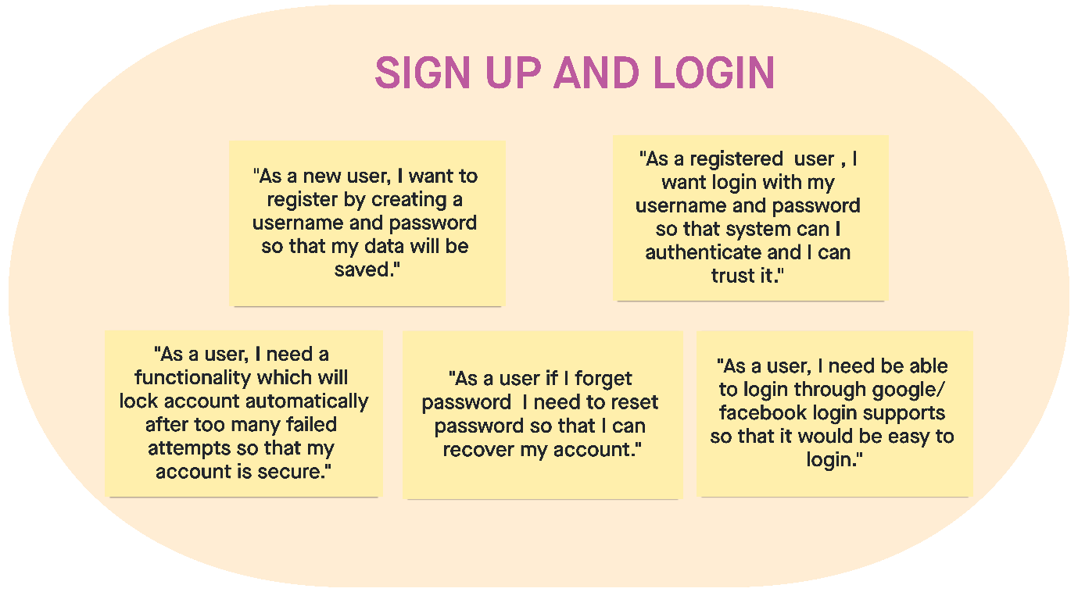

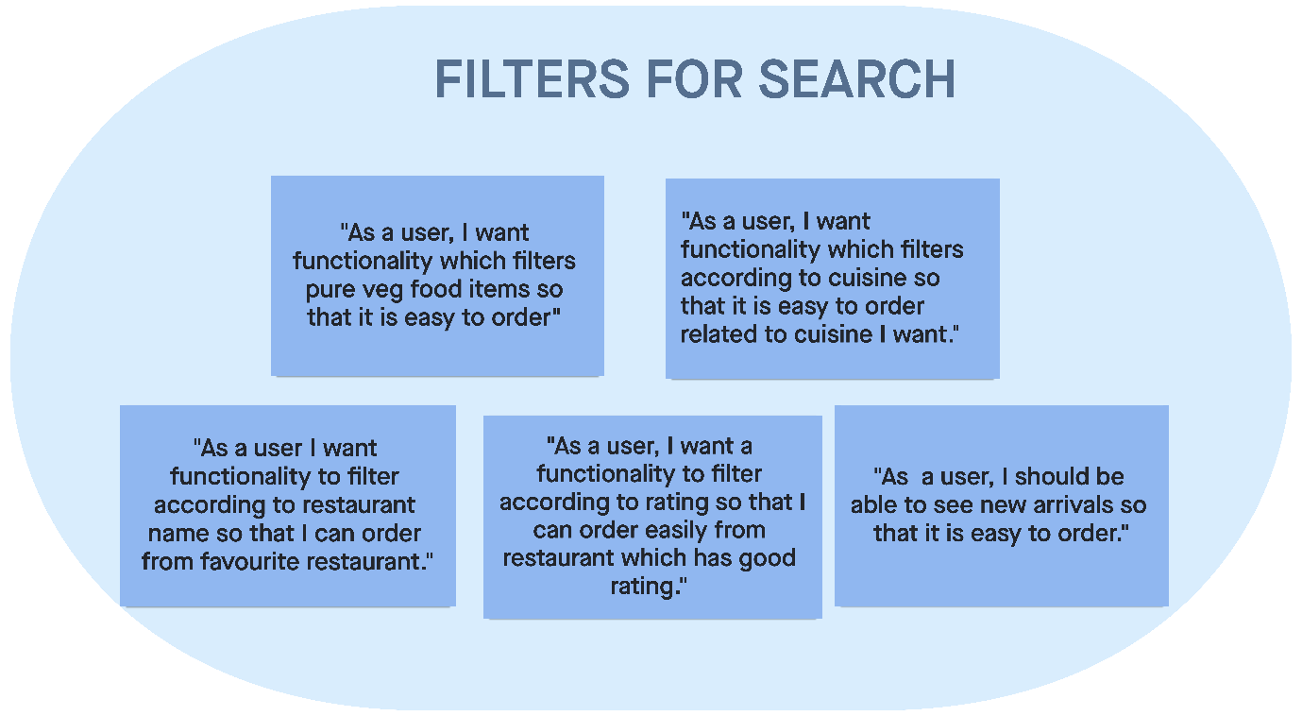

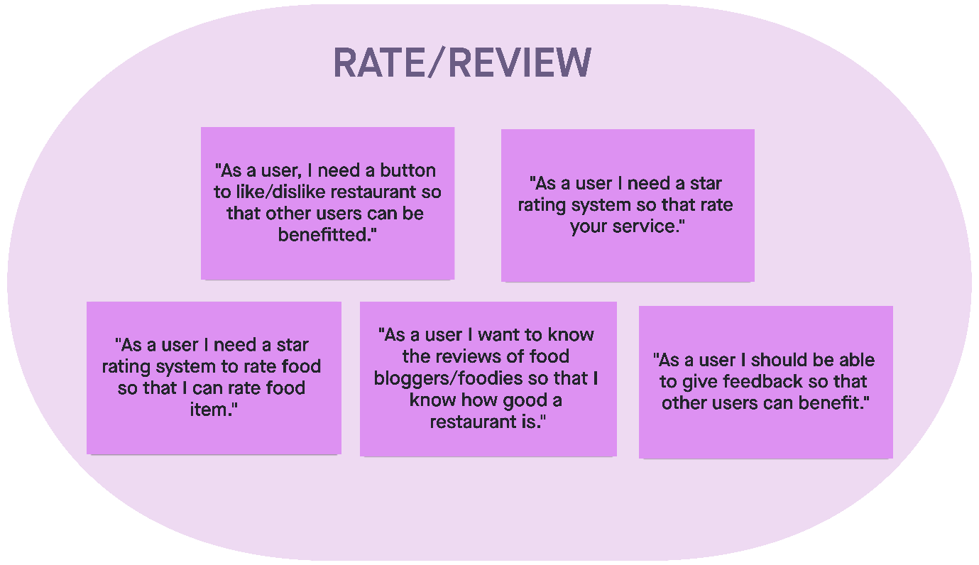

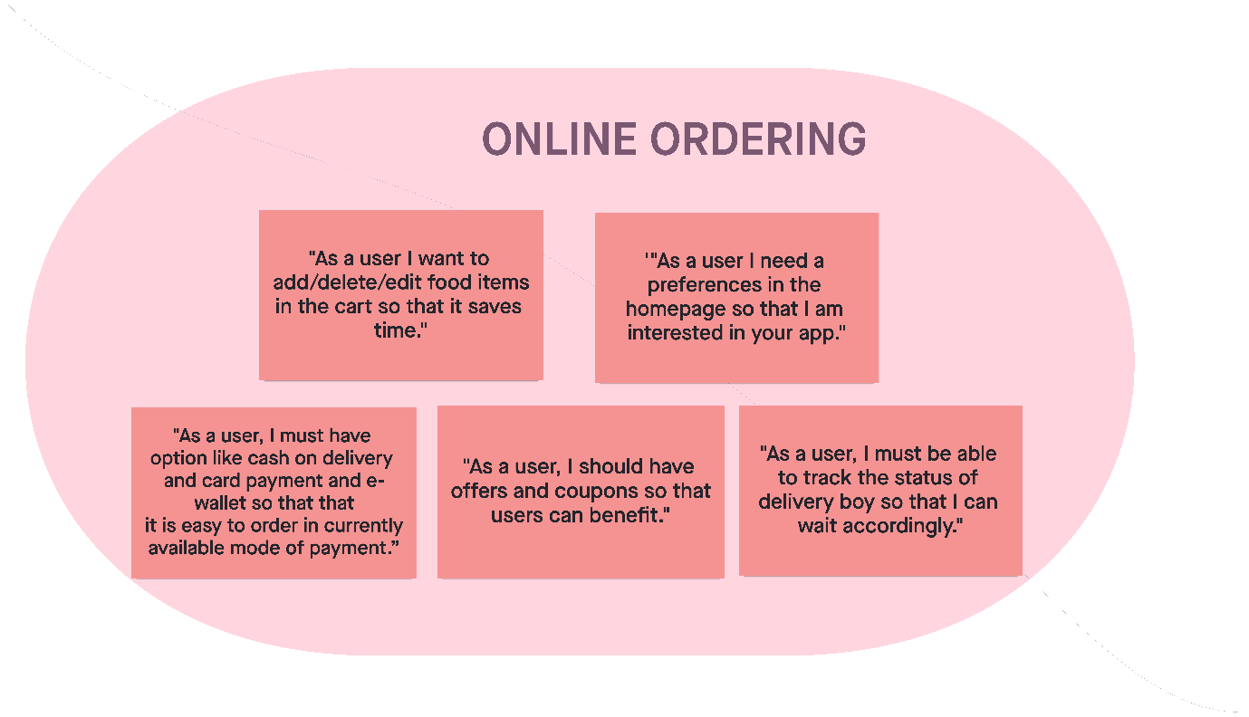

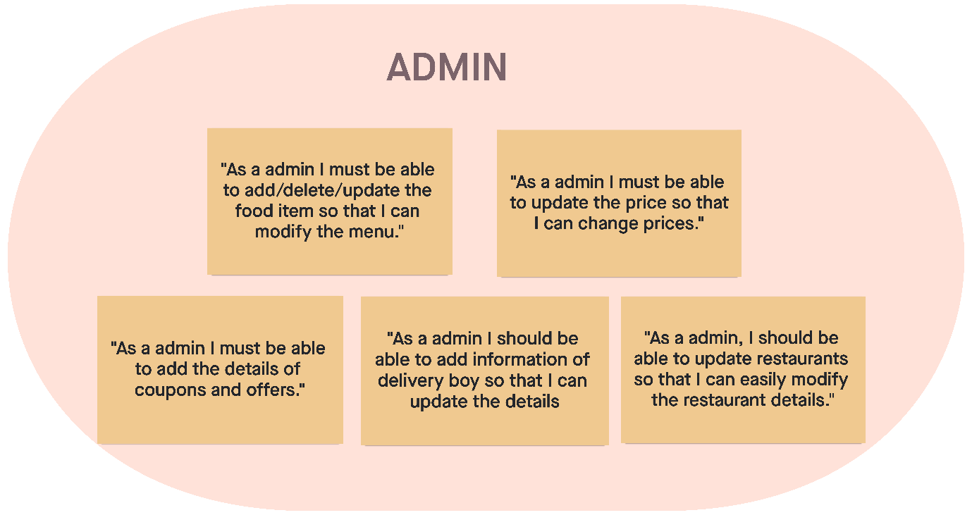

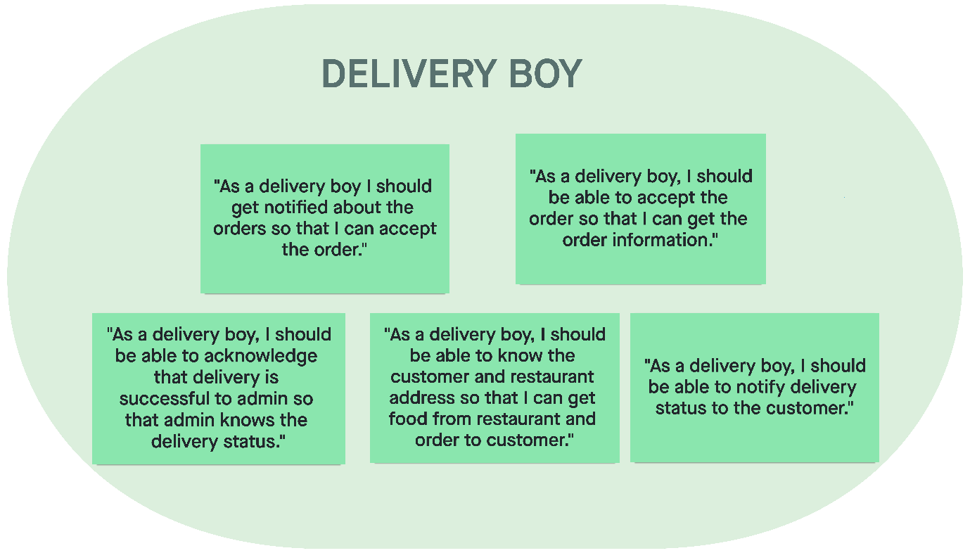

**Estimation:**

|  |  |
| --- | --- |
| **SIGN UP AND LOGIN - 16** | |
| **USER STORY** | **ESTIMATE** |
| **"As a new user, I want to register by creating a username, mail, phone number and password so that my data will be saved."** | 3 |
| **"As a registered user, I want login with my username and password so that system I can authenticate and I can trust it."** | 3 |
| **"As a user, I need a functionality which will lock account automatically after too many failed attempts so that my account is secure."** | 5 |
| **"As a user if I forget password, I need to reset password so that I can recover my account."** | 3 |
| **“As a user, I need be able to login through google/ Facebook login supports so that it would be easy to login.”** | 2 |

|  |  |
| --- | --- |
| **FILTERS FOR SEARCH -17** | |
| **USER STORY** | **ESTIMATE** |
| **"As a user, I want functionality which filters pure veg food items so that it is easy to order"** | 3 |
| **“As a user, I want functionality which filters according to cuisine so that it is easy to order according to my taste.”** | 5 |
| **“As a user I want functionality to filter according to restaurant name so that I can order from favourite restaurant.”** | 2 |
| **“As a user, I want a functionality to filter according to rating so that I can order according to majority points.”** | 4 |
| **“As a user, I should be able to see new arrivals so that it is easy to order.”** | 3 |
| **RATE/REVIEW -14** | |
| **USER STORY** | **ESTIMATE** |
| **As a user, I should be able like/dislike restaurant so that other users can be benefitted."** | 2 |
| **"As a user I need a star rating system so that rate your service."** | 3 |
| **"As a user I need a star rating system to rate food so that I can rate food item."** | 3 |
| **"As a user I want to know the reviews of food bloggers/foodies so that I know how good a restaurant is."** | 4 |
| **"As a user I should be able to give feedback so that other users can benefit."** | 2 |

|  |  |
| --- | --- |
| **ONLINE ORDERING -21** | |
| **USER STORY** | **ESTIMATE** |
| **"As a user I want to add/delete/edit food items in the cart so that it saves time."** | 5 |
| **"As a user I need a preference in the homepage so that I am interested in your app."** | 3 |
| **"As a user, I must have option like cash on delivery and card payment and e-wallet so that it is easy to order according to my availability.”** | 4 |
| **"As a user, I should have offers and coupons so that users can benefit."** | 4 |
| **"As a user, I must be able to track the status of delivery boy so that I can wait accordingly."** | 5 |

|  |  |
| --- | --- |
| **ADMIN - 17** | |
| **USER STORY** | **ESTIMATE** |
| **"As an admin I must be able to add/delete/update the food item so that I can modify the menu."** | 5 |
| **"As an admin I must be able to update the price so that I can change prices."** | 4 |
| **"As an admin I must be able to add the details of coupons and offers."** | 3 |
| **"As an admin I should be able to add information of delivery boy so that I can update the details** | 3 |
| **"As an admin, I should be able to update restaurants so that I can easily modify the restaurant details."** | 2 |

|  |  |
| --- | --- |
| **DELIVERY BOY - 21** | |
| **USER STORY** | **ESTIMATE** |
| **"As a delivery boy I should get notified about the orders so that I can accept the order."** | 5 |
| **"As a delivery boy, I should be able to know the customer and restaurant address so that I can get food from restaurant and order to customer."** | 5 |
| **"As a delivery boy, I should be able to accept the order so that I can get the order information."** | 4 |
| **"As a delivery boy, I should be able to acknowledge that delivery is successful to admin so that admin knows the delivery status."** | 3 |
| **"As a delivery boy, I should be able to notify delivery status to the customer."** | 4 |